ATLANTIC TECHNOLOGICAL UNIVERSITY

ASSIGNMENT COVER SHEET

To Be Completed by The Student

Lecturer’s Name: Ms. Ruth Lennon

Assessment Title: Broken Legacy Code

Submission Date: 31/08/2023

Student’s Name: Goran Kraljic Id. Number: L00162123____

Course / Stage PgDip in DevOps

Subject/Module: IaC for DevOps Pipelines (2022/23)

Word Limit: Actual Word Count: _______________

I confirm that the work submitted has been produced solely through my own efforts.

Student’s signature: Goran Kraljic Date: 31/08/2023

|  |
| --- |
| **Note**: **PENALTIES**   * The total marks available for an assessment will be reduced by 15% for work submitted up to one week late. The total marks available are reduced by 30% for work up to two weeks late. * Assessment work received more than two weeks late, without prior approval by the lecturer will receive a mark of zero. * Marks awarded will be reduced by 10 % if submitted work is greater than 10% above or below the assigned word limit. * A further hard or electronic copy of your submitted work may be requested, and therefore you must keep a copy on disc. * Incidents of alleged plagiarism and cheating are dealt with in accordance with the Institute’s Assessment Regulations   **Plagiarism:** Presenting the ideas, words of someone else without proper acknowledgement. Refer to the Institutes’ procedures and guidelines for the assessment of learners. |

# 1. DevOps implementation framework

Assignment presenting us with situation where resources are very limited. Company suffers from high attrition. High attrition always brings significantly reduced capability for change. This reduced capability is because of lost knowledge. Other negative knock on effects are felt across the company in form of increased workload, increased backlog, constant increase of technical debt, high dispositional resistance, failed change initiatives and projects.

Employees are aware that company is failing and that job security is just a distant memory. This kind of situation weighs heavy on everyone and personal initiative is almost non-existent.

Most of employees and management are in constant fire-fighting mode where shortcuts are taken in order to tackle one fire but these same shortcuts create another fire. All mentioned elements are root cause for ever increasing technical debt which in turn leads to longer and longer time to market and customer dissatisfaction or worst case scenario customer attrition.

Company correctly identified that structural changes won’t make any improvement in their situation that only thing that can help them is cultural change which must start from inside of the company. Cultural change cannot be pushed, cultural change must be offered and it must involve all the stakeholders.

Modernization of internal processes requires participation of all stakeholders from ground up and processes needs to be assessed from the point of view that, every individual process is element of much larger system. This is extremely important because it is part of human nature that middle level management looks only their own area of responsibility and solution in one area often creates problem in another area of responsibility.

Since this is first attempt of the company to bring in DevOps introduction of The Three Ways framework is a necessity. The Three Ways is bottom-up approach which will utilize all remaining resources in company. It will help all stakeholders to learn about company and it will build “tribal knowledge” based on actual cases. The Three Ways will immediately tackle most common pitfalls which are damaging to whole organization: unplanned work, status of work in progress, technical debt, resource availability, communication feedback loop, constraints identification, work release, standardization of recurring work.

Emphasis will be on use of existing resources. My team consists of Ren and Jalen.

Ren is senior engineer with a lot of experience within the company. He was in a company from very begging but unfortunately he worked on only one product and this product is discontinued. From him team won’t gain much from innovation or modern approaches but team will get wealth of information about internal processes and current state. My first goal is to secure a buy in from him in order to utilise him as person who will point me to individuals which I will need to tackle existing problems. Another extremely important role for him will be to promote DevOps on individual level where he would alleviate fear of change and dispositional resistance in other experienced employees and normally convey findings back to me.

Jalen is a new graduate and it has natural desire to prove himself. This project is for him precisely what he needs. Due to this he will be willing to accept changes and new technologies and methodologies. This makes him crucial part of the team for all types of work that will require innovation and learning. He will be ideal support to teams that will work on code modernization and he will serve as person who will enhance feedback loop between operations and developers.

## 1.1 Steps in new DevOps implementation framework

Since company is in difficult situation and time and resources are very limited, focus in this new approach is on cost saving and time to market. It involves research, experimental part and testing but limited only to internal processes. Most important feature is that this framework is completely scalable and as in-company processes mature it will prepare the groundwork to implement more comprehensive framework like CALMS which would tackle all aspects of organization.

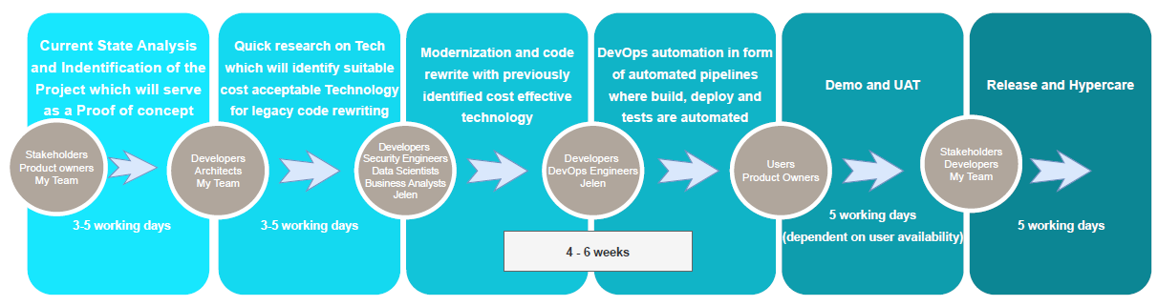

Fig. 1: Steps in new DevOps implementation framework

### 1.1.1 Current State Analysis and Identification of the suitable project

In this step information’s about current state of business will be gathered so my team can identify problems and opportunities. We will identify all stakeholders, define scope of the analysis, gather data, analyse gathered data and do a basic documentation of findings.

During defining the scope, we will identify specific area of our attention.

Data gathering will have two steps. In first one we will skim through available official data and identify the patterns and in second step we will use interviews to get more visibility and clarity on gathered data from key stakeholders.

Focus of this step is to identify suitable project which will demonstrate that DevOps can bring significant cost saving and improve time to market for company products. Ideally without of bringing additional manpower into equation.

### 1.1.2 Quick research on Technology for legacy code rewriting

In this step with help of stakeholders we will define the requirements, identify available technologies, evaluate this technologies, talk to developers which actually are working with considered technology and do a basic test of selected technology stack. Test is required in order to confirm that selected technology stack is in line with our previously defined requirements.

In evaluation my team and stakeholders will focus on maturity of technology, general popularity of evaluated technology, extent of community support and above all security.

During evaluation strong consideration will be on existing skills of my team member Jelen, the budget available and the timeline available. Chosen Technology stack shouldn’t require extremely complex training.

### 1.1.3 Modernization and code rewrite

Modernization and code rewrite step will first take into consideration age and complexity of legacy code. Selected project was partially chosen because it is old legacy code and it is in line with business requirements. During current state analysis was identified that it requires refactoring and it can be done within of the timeline and budget. Since refactoring is low-risk approach in this case Jelen will focus on readability, maintainability and performance. The most visible benefit of refactoring approach is that refactoring can be done incrementally.

### 1.1.4 DevOps automation

Due to dire situation in company, cost reduction is imperative. Attrition caused workforce shortages so expectance is that we deliver more with less resources. Answer to this requirement lies in DevOps automation. Source control system will be heart of DevOps implementation. As Jelen is progressing with code refactoring, code will be committed to repository. Source control system will track changes, code will be available to other stakeholders, it will serve for task automation. Code in Source control system will have significantly improved visibility which will in turn help with better understanding of code and code dependencies. It will enable branching which will considerably reduce risk of implementing errors in code with refactoring.

Introduction of CI/CD pipelines in this step will bring automated testing, continuous delivery and continuous deployment. These elements will significantly reduce unplanned work, work in progress and contribute to technical debt reduction which in turn will reduce time to market and costs. Positive knock one effects will be in a form of reduced individual work load, reduced wait time, increased number of cycles and above all higher throughput of the whole system.

### 1.1.5 Demo and UAT

In order to confirm that code is aligned with stakeholder requirements Demo will be in front of key stakeholders. It will serve to get final feedback on functionality, usability or design and confirmation that refactored code is ready for UAT testing.

During UAT software will be tested by our internal end users and it will as well help to identify issues during unit testing or module testing.

### 1.1.6 Release and Hypercare

As a last step we have release and hypercare. In this step product is released but it is not final iteration and free of bugs. Hypercare is there to tackle issues that are more of cosmetic nature and everything else will be sent into further iterative development.

# Code modernization process

Considering the overall situation in company, emphasis is on quick turnaround with focus on throughput increase.

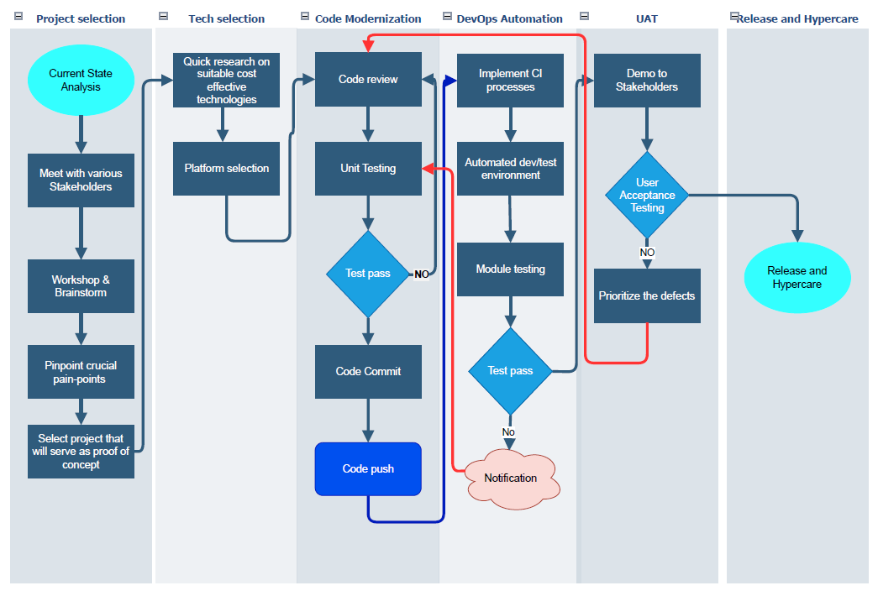

Fig. 2 Modernization process

Code Modernization and DevOps Automation are 2 crucial steps with predicted time 4 – 6 weeks.

Risk factor was one of selection criteria. Since code refactoring inherently has a lower risk factor, project that requires code refactoring was selected.

Jelen will tackle coding while Ren will serve as liaison between stakeholders and Jelen. Communication with stakeholders and value that it brings will be emphasised on every management meeting.

## 2.1 Code review

In code review current state of the legacy code will be assessed. Team will identify are there security vulnerabilities present, are there any performance issues or is there any technical debt related to it. Team will gain actual understanding of code and produce business cases.

After current state is confirmed team will confirm scope of refactoring effort which will enable better control of the scope creep in later phases. When scope is defined Team will select refactoring approach which will depend mostly on specific problems that were identified during current state review. With refactoring approach selected, Jelen will proceed with implementation of refactoring changes. Stakeholders will be required to confirm all the findings and will be active participant in every step.

## 2.2 Unit Testing

Unit testing will test that changes to legacy code won’t introduce any new bugs to existing legacy code. It will test separate components in isolation.

In most of situations old legacy code has almost non-existent documentation so with test writing existing code will reveal its behaviour and requirements.

If unit testing fails code is returned back to code review where identified errors are examined, prioritized and corrected.

Some stakeholders may not see value in unit test but value will be visible in later stages as significant reduction of unplanned work, increased confidence, better quality of code, easier maintenance and reduced risk.

Unit testing is crucial element of continuous improvement.

## 2.3 Source control system

In legacy code refactoring code commit would be a critical step because source control system is tracking changes and this is allowing reverting code to previous version if necessary. Additional benefits of using source control system in this regard are enhanced collaboration and version control. All changes to code will be documented this will help in building of “tribal knowledge” which will in turn produce positive effects in reducing workload on senior engineers. When source controls system is correctly utilised and unit testing is in place risk is significantly reduced, stability of the code is increased and in this capacity it serves as foundation for further improvements.

## 2.4 DevOps automation

DevOps automation will drastically increase efficiency of the process. Repetitive tasks are streamlined and human error is reduced to smallest possible amount. With automation, team will ensure that outcomes are reliable and consistent.

Continuous Integration (CI) pipelines are core DevOps practice which will automate build, test and deploy. Code will be integrated in single repository. Build will pull latest changes from repository and executable artefact will be created. CI server will run automated test and if test is successful CI server will deploy changes to staging environment. In staging environment changes will be confirmed by other stakeholders. Every stage of CI pipeline will provide feedback to developers.

Automated testing will detect defects early in the process which will directly reduce unplanned work in deployment. Any reduction in unplanned work will increase throughput of the system which in turn will bring higher number of cycles. One of important elements is that all constraints will be visible. With visible constraints it will be easier to calculate wait time. Wait time is extremely important because it directly increases work in progress. If developer is 99% utilized that means that any new work that arrives at his table will have to wait 99 time longer than it would wait if developer is 50% utilized. Since repetitive tasks will be automated waiting time will be directly reduced and positive knock on effects will be felt trough system.

# Conclusion

Goal of the DevOps framework which was presented is to address the challenges of the company which clearly didn’t follow any of the work management methodologies in the past. Since time is main limiting factor focus is placed on strategic steps which emphasize cost saving and time to market improvements. Framework is enabling the company to bring in effective change and scalability but it is taking in account limited resources and challenging circumstances. The main distinction between this change and previous change initiatives is that this change will lay down foundation for true cultural change with Continuous Improvement at its hart.

Pivotal element of this change is that it is offered and not pushed and all stakeholders are involved and participating in every step with emphasis on communication and feedback loop.

Structured process that this framework follows enables quick results and iterative improvements. Quick results and iterative improvements will serve as business case for more encompassing CALMS-based framework in the future which will tackle all aspects of organization.

Starting point of this framework is analysis of current state of the company and work portfolio. This starting point allows the team to identify key stakeholders, gather relevant data, define scope of the analysis, pinpoint subject matter experts that may contribute to development. Even this starting point directly contributes to cost and risk reduction which is securing buy in from management.

Other steps during implementation are research on suitable technology stack, modernizing and code refactoring, DevOps automation implementation are reconfirming dedication to cost reduction, resource utilization and risk management.

Implementation of Continuous Integration and Continuous Delivery pipelines have a “game changer” role in reduction of unplanned work, increase of code quality and reducing “time to market” (in this case internal users). Approach emphasizes communication, collaboration and iterative development as cornerstones of achieving the targeted results.

If company adheres to principles of presented framework, benefits will be substantial and mainly identifiable trough reduced technical debt, reduced work in progress, reduced unplanned work, increased system throughput, higher resource efficiency, better alignment between company goals and employees.

Emphasis on scalability guarantees that as introduced processes mature company can move into more thorough frameworks or even develop custom made framework which would include all aspects of machine learning and forecasting.

This DevOps implementation framework provides a strategic roadmap for the company to tackle current and future challenges, implement DevOps principles, and achieve long-term success.